
SRM Institute of Science and Technology
Register Number
College of Engineering and Technology
School of Computing
SRM Nagar, Kattankulathur – 603203, Chengalpattu District, Tamilnadu
Academic Year: 2024 - 25 EVEN
B.Tech-Networking and Communications (CS Cyber Security and Digital Forensics (Integrated)
Test: CT 1 Date: 21.2.2025
Course Code & Title: 21CSE356T – Natural Language Processing Duration: 2 periods
Sem: VI Sem Max. Marks: 50
Batch & Set: II & B
Course Articulation Matrix:
S.No. |  | Course Outcome |  | PO1 | PO2 | PO3 | PO4 | PO5 | PO6 | PO7 | PO8 |  | PO9 | PO 10 |  | PO 11 |  | PO 12 |  | PSO 1 |  | PSO2 | PSO3
1 |  | CO1 |  | 2 |  | 3 |  | 3
2 |  | CO2 |  |  |  | 3
3 |  | CO3 |  | 2 |  | 3 |  |  |  |  |  |  |  |  |  |  |  |  |  |  |  |  | 3
4 |  | CO4 |  |  |  | 3 |  | 3 |  |  |  |  |  |  |  |  |  |  |  |  |  |  | 3
5 |  | CO5 |  |  |  |  |  | 3
Part – A
Answer all questions (10 x 1=10 marks)
 | Q. No |  | Question |  |  |  |  |  |  |  |  | Marks |  |  | BL |  | CO |  | PO |  | PI Code
 |  |  | What is the process of converting words into their base or root form called?  a) Tokenization  b) Stemming  c) Lemmatization  d) Part-of-speech tagging |  |  |  |  |  |  |  |  | 1 |  |  | 2 |  | CO3 |  | 1 |  | 2.6.1
 |  |  | C (b also answer, Since stemming may give meaningless words, c is chosen)
 |  |  | What is the purpose of the Bag-of-Words (BoW) model in NLP?  a) To represent words as vectors  b) To calculate word frequencies  c) To identify syntactic dependencies  d) To perform sentiment analysis |  |  |  |  |  |  |  |  | 1 |  |  | 2 |  | CO4 |  | 1 |  | 2.6.2
 |  |  | b
 |  |  | Which of the following is an example of a stop word?  a) keyboard  b) letter  c) Airplane  d) The |  |  |  |  |  |  |  |  | 1 |  |  | 2 |  | CO4 |  | 1 |  | 2.6.1
 |  |  | d
 |  |  | What is TF-IDF in the context of NLP?  a) A deep learning model  b) A feature extraction technique  c) A sentiment analysis algorithm  d) A speech recognition method |  |  |  |  |  |  |  |  | 1 |  |  | 2 |  | CO4 |  | 1 |  | 2.6.1
 |  |  | b
 |  |  | Regular Expression for IFSC Code  a)^[A-Z]{4}0[A-Z0-9]{6}$  b) ^[A-Z]{4}0[A-Z]{6}$  c) ^[A-Z]{4}0[0-9]{6}$  d) ^[A-Z]{4}0[A-Z0-9]{5}$ |  |  |  |  |  |  |  |  | 1 |  |  | 2 |  | CO3 |  | 1 |  | 2.6.2
 |  |  | a The Indian Financial System Code (IFSC) is an 11-character alphanumeric code used to identify bank branches in India. The structure of an IFSC code follows this pattern: First 4 characters: Always uppercase letters (A-Z), representing the bank code. 5th character: Always 0 (reserved for future use). Last 6aracters: Can be either letters (A-Z) or digits (0-9), representing the branch code.
 |  |  | How is the word "changing" lematized?  - chang  - changin  - chan  - change |  |  |  |  |  |  |  |  | 1 |  |  | 2 |  | CO4 |  | 3 |  | 2.6.1
 |  |  | d
 |  |  | "I bought a beautiful dress at the mall". The part of speech of underline word is_____  - Preposition  - Adjective  - Noun  - Adverb |  |  |  |  |  |  |  |  | 1 |  |  | 2 |  | CO3 |  | 1 |  | 2.6.1
 |  |  | b
 |  |  | How Many Different Lexemes Are There In The Following List?Man, Men, Girls , Girl , Mouse  - 2  - 3  - 1  - 4 |  |  |  |  |  |  |  |  | 1 |  |  | 2 |  | CO3 |  | 1 |  | 2.6.1
 |  |  | b
 |  |  | Software designed for taking i/p data(text) and give structural representation of the input after checking the correct syntax or grammar is  - Compiler  - Parser  - Painter  - Easydraw |  |  |  |  |  |  |  |  | 1 |  |  | 2 |  | CO3 |  | 1 |  | 2.6.1
 |  |  | b
 |  |  | How many bi-grams can be generated from given sentence:- "This is NLP book."?  - 3  - 2  - 4  - 1 |  |  |  |  |  |  |  |  | 1 |  |  | 2 |  | CO4 |  | 3 |  | 3.6.2
 |  |  | a

Register Number

SRM Institute of Science and Technology
College of Engineering and Technology
School of Computing
SRM Nagar, Kattankulathur – 603203, Chengalpattu District, Tamilnadu
Academic Year: 2024 - 25 ODD
M.Tech-Networking and Communications (CS Cyber Security and Digital Forensics (Integrated)
Test: FT3 Date: 08.10.2024
Course Code & Title: 21CSE489T Mobile and Wireless Security Duration: 2 periods
Sem: VII Sem Max. Marks: 50
Batch & Set: II & B

Part –B
Answer ALL questions (4 x 5=20 marks)
Q. No | Question | Marks | BL | CO | PO | PI Code
11.a. | Given a set of unigram and bigram probabilities, what is the probability of the following sequence ‘do Sam I like’ according to the bigram language model? P(do|) = 2/11, P(do|Sam) = 1/11, P(Sam|) = 4/11, P(Sam|do) = 1/8, P(I|Sam) = 4/11, P(Sam|I) = 2/9, P(I|do) = 2/8, P(I|like) = 2/7, P(like|I) = 3/11, P(do) = 3/8, P(Sam) = 2/11, P(I) = 4/11, P(like) = 5/11 | 5 | 4 | CO3 | 3 | 3.6.2
Probability w.r.t each term 1 mk each
Final probability 1 mk

To calculate the probability of the sequence "do Sam I like" using the bigram language model, we use the chain rule of probability:
P(W1,W2,W3,W4)=P(W1)P(W2∣W1)P(W3∣W2)P(W4∣W3)
Given sequence: "do Sam I like"
We need to compute:
P(do)×P(Sam∣do)×P(I∣Sam)×P(like∣I)
From the given probabilities:
- P(do)=3/8
- P(Sam∣do)=1/8
- P(I∣Sam)=4/11
- P(like∣I)=3/11
Now, multiplying:
P(doSamIlike)=(3/8)×(1/8)×(4/11)×(3/11)
=(3×1×4×3) / (8×8×11×11)=
=36 / 7744 ≈0.00465
Final Answer:
36/7744
approximately 0.00465.

 | (OR)
11.b. | What is the difference between stemming and lemmatization? | 5 | 4 | CO3 | 3 | 3.6.2
4-5 points for each
2.5 mk each

Feature | Stemming | Lemmatization
Definition | Reduces words to their root form by removing suffixes | Converts words to their dictionary base form (lemma)
Approach | Uses heuristic rules (e.g., chopping off "ing", "ed") | Uses linguistic knowledge (word meaning, POS)
Accuracy | Less accurate (may produce non-dictionary words) | More accurate (produces meaningful words)
Example 1 ("running") | runn | run
Example 2 ("better") | better | good
Speed | Faster (simpler rules) | Slower (requires NLP processing)
Usage | Quick and simple applications like search engines | Advanced NLP tasks like chatbots, machine translation

12.a. | Perform parsing using simple top-down parsing for the sentence “the dog cried” using the grammar given below  S-> NP VP  NP->ART N  NP-> ART ADJ N  VP->V  VP->V NP | 5 | 3 | CO3 | 3 | 3.6.1
12.a. | Terminal productions 1.5 mk  Scanning from start to sentence 2.5 mk  Parse tree 1 mk  Parsing "the dog cried" using Simple Top-Down Parsing  Given Grammar:  S → NP VP  NP → ART N  NP → ART ADJ N  VP → V  VP → V NP  Step-by-Step Parsing for "the dog cried"  Sentence: "the dog cried"  Lexical categories:  "the" → ART (article)  "dog" → N (noun)  "cried" → V (verb)  Step 1: Start with S → NP VP  → ART N VP  → the N VP  → the dog VP  → the dog cried  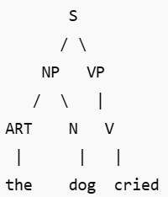
 | (OR)
12.b. | How Semantic analysis is different from Pragmatic analysis?  At least 4-5 point for each  2.5 mk each | 5 | 4 | CO4 | 3 | 3.6.2
12.b.
  Feature | Semantic Analysis | Pragmatic Analysis
  Definition | Focuses on the literal meaning of words, phrases, and sentences. | Focuses on the contextual meaning and how meaning changes based on situation, speaker, and intent.
  Concerned With | Meaning independent of context (word meanings, sentence structure). | Meaning dependent on context (speaker’s intention, sarcasm, tone).
  Example 1: "I saw a bank." | Interprets "bank" as a financial institution or riverbank based on word definitions. | Determines the meaning based on context (e.g., if talking about money, "bank" refers to a financial institution).
  Example 2: "Can you pass the salt?" | Interprets literally as a yes/no question. | Understands that it is actually a polite request, not a question.
  Methods Used | Lexical semantics, syntax analysis, word sense disambiguation. | Discourse analysis, context modeling, speech act theory.
  Application Areas | Machine translation, sentiment analysis, information retrieval. | Chatbots, conversational AI, sarcasm detection, humor understanding.
13.a. | Write a short note on the following:  - One Hot encoding  - Bag of words | 5 | 4 | CO3 | 3 | 3.6.4
13.a. | a explanation 1.5 mk  ex: 1 mk  b explanation 1.5 mk  ex: 1 mk  (a) One-Hot Encoding  Definition:  One-Hot Encoding is a technique used to convert categorical text data into numerical format. Each unique word (or token) is represented as a binary vector, where only one position is "1" (indicating the word’s presence), and all others are "0".  Example:  For the words ["cat", "dog", "fish"], the one-hot encoding would be:  "cat" → [1, 0, 0]  "dog" → [0, 1, 0]  "fish" → [0, 0, 1]  Pros:  Simple and easy to implement  Preserves uniqueness of words  Cons:  High dimensionality for large vocabularies  Does not capture relationships between words  (b) Bag of Words (BoW)  Definition:  Bag of Words is a feature extraction technique in NLP that represents a text as a set of words, ignoring grammar and word order but keeping word frequency.  Process:  Create a vocabulary of unique words from all documents.  Represent each document as a vector of word frequencies.  Example:  For sentences:  "The dog barks."  "The cat meows."  Vocabulary: ["The", "dog", "barks", "cat", "meows"]  Vectors:  Sentence 1 → [1, 1, 1, 0, 0]  Sentence 2 → [1, 0, 0, 1, 1]  Pros:  Simple and effective for text classification tasks  Good for document similarity and text clustering  Cons:  Ignores word order and context  Leads to sparse matrices for large vocabularies
 | (OR)
13.b. | Explain in detail about smoothing technique with example? | 5 | 4 | CO4 | 3 | 3.6.2
13.b. | Explanation 2 mk  Any one technique 1 mk  Ex: 2 mk  In Natural Language Processing (NLP), smoothing is a technique used to handle situations where some events have zero or very low probability. It is particularly important in probabilistic models like n-gram language models, where some word sequences may not appear in the training corpus but still need to be assigned a probability.  For example, in an n-gram model, if we estimate the probability of a word sequence P(wn∣wn−1)we might encounter cases where a particular sequence never appears in the training data, resulting in zero probability. Smoothing helps mitigate this issue by adjusting probability estimates.  Laplace Smoothing (Add-One Smoothing)  Laplace smoothing is one of the simplest techniques. It adds a small constant (usually 1) to all frequency counts to ensure no probability is zero.  Formula:  For a unigram model:  P(w)=count(w)+1 / N+V  For a bigram model:  P(wn∣wn−1) = (count(wn−1,wn)+) / count(wn−1​)+V  where:  V = vocabulary size (number of unique words)  N = total word count in the corpus  Example:  Suppose we have the following corpus:  "the cat sat on the mat"  Vocabulary (V) = {the, cat, sat, on, mat} (5 words)  Unsmoothed probabilities:  P(sat∣cat)=count(cat,sat) / count(cat)  If count(cat, sat) = 0, then P(sat∣cat)=0, which is problematic.  Using Laplace Smoothing:  P(sat∣cat) =(0+1) / (1+5)=1 / 6  This ensures that all bigrams get a nonzero probability.
14.a. | Explain Probabilistic Context-Free Grammars with example | 5 | 4 | CO4 | 3 | 3.6.2
14.a. | PCFG 2mk  Ex: 2 mk  A Probabilistic Context-Free Grammar (PCFG) is an extension of a Context-Free Grammar (CFG) where each production rule is assigned a probability. These probabilities help in disambiguating sentences and ranking different possible parse trees in natural language processing (NLP).  PCFGs are widely used in:  Natural Language Parsing  Speech Recognition  Syntax-Based Machine Translation  A PCFG assigns a probability to each production rule. The probability of a parse tree is the product of the probabilities of all its rules.  A PCFG satisfies the condition:  ∑P(A→α)=1  for all non-terminals A, ensuring that the sum of probabilities for each set of rules is normalized.  Example PCFG  Given a sentence "John saw the dog", we compute its probability:  S → NP VP (1.0)  NP → ProperNoun ("John") (0.4)  VP → V NP (1.0)  V → "saw" (0.4)  NP → Det N (0.6)  Det → "the" (0.7)  N → "dog" (0.5)  P("John saw the dog")=1.0×0.4×1.0×0.4×0.6×0.7×0.5=0.0336  The higher the probability, the more likely the sentence structure.
 | (OR)
14.b. | Write a short note on:  - Context Free Grammars  - Properties of Context Free Grammars  - Conversion of Context Free Grammars to CNF grammar  Illustrate with examples in necessary places. | 5 | 3 | CO4 | 3 | 3.6.2
14.b. | a 2 mk  b 1 mk  c 2 mk  A context-free grammar (CFG) is a set of production rules used to generate all the possible sentences in a given language. A CFG consists of a set of terminals, which are the basic units of the language, and a set of non-terminals, which are used to generate the terminals through a set of production rules.  A CFG is represented as:  G = (N, Σ, P, S)  where:  - N = Set of non-terminal symbols (e.g., S, NP, V, P)  - Σ = Set of terminal symbols (e.g., words like "cat", "chased")  - P = Set of production rule  - S = Start symbol  Properties:  Closure Properties: CFGs are closed under union, concatenation, and Kleene star but not under intersection and complement.  Ambiguity: A grammar is ambiguous if a string has more than one valid parse tree.  Derivations: Can be leftmost (always expand the leftmost non-terminal first) or rightmost.  Pumping Lemma: Used to prove that certain languages are not context-free.  Parsing Complexity: CFGs can be parsed using algorithms like CYK (O(n³) complexity).  Ex: (Ambiguity)  S → S + S | S * S | (S) | a  For the string "a + a * a", multiple parse trees exist, making the grammar ambiguous.  CNF:  A Chomsky Normal Form (CNF) grammar has rules of the form:  A→BC (where B,C are non-terminals)  A→a (where a is a terminal)  S→ε (optional if empty string is allowed)  Steps to Convert CFG to CNF:  Remove Null (ε) Productions  Remove Unit Productions (A → B where B is a single non-terminal)  Remove Useless Productions  Convert Long Productions to Binary Form  Ex:  S→AB  A→a | ε  B→b  Remove Null production  S→AB  A→a  B→b Now the grammar is in CNF

Part –C
Answer any 2 questions (2 x 10=20 marks)
Q. No | Question | Marks | BL | CO | PO | PI Code
15.a. | What is meant by TF-IDF? Find out the relevant term in the given corpus using TF-IDF. | 10 | 5 | CO4 | 3 | 3.6.2
15.a. | TF 2 marks  IDF 2 marks  Problem 6 marks  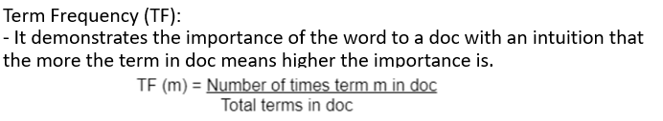  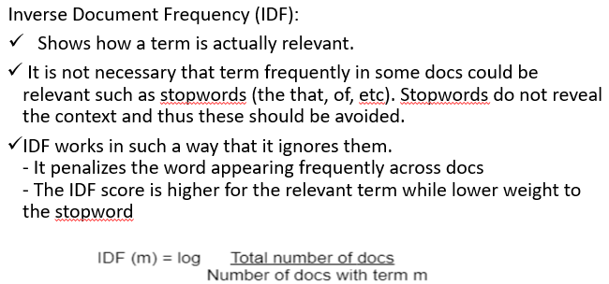  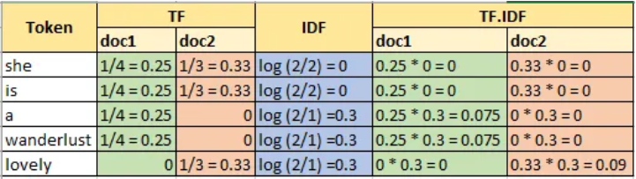
 | (OR)
15.b. | Explain in brief about four NLP products you use in day to day life. | 10 | 5 | CO3 | 3 | 3.6.2
15.b. | 2.5 marks each  1. Virtual Assistants (e.g., Siri, Google Assistant, Alexa)  Function: Understand and respond to voice commands.  NLP Usage: Uses speech recognition, natural language understanding (NLU), and text-to-speech (TTS) to process and respond to user queries.  Example: Asking Google Assistant, "What’s the weather today?"  2. Search Engines (e.g., Google Search, Bing)  Function: Retrieves relevant information based on user queries.  NLP Usage: Uses query understanding, synonym matching, and context-aware ranking to show relevant results.  Example: Searching "best smartphones under $500" and getting relevant recommendations.  3. Chatbots (e.g., Customer Support Bots on Websites)  Function: Provides automated customer support.  NLP Usage: Uses intent detection, entity recognition, and context-aware conversation for responding to user queries.  Example: A bank’s chatbot answering "How can I check my account balance?"  4. Auto-Correct and Predictive Text (e.g., Grammarly, Google Keyboard)  Function: Improves writing by correcting grammar and predicting words.  NLP Usage: Uses language modeling, error detection, and contextual prediction.  Example: Google Keyboard suggesting "meeting at 5 PM?" when typing "meet".
16.a. | What is meant by CKY Parsing? Explain the steps to be followed in CKY parsing. Check whether the string baaba belongs to the given grammar using CKY parsing  S -> AB | BC  A -> BA | a  B -> CC | b  C -> AB | a | 10 | 5 | CO3 | 3 | 3.6.2
16.a. | CKY Parsing 3 marks  Verify CNF 2 marks  CKY table 4 marks  Checking for membership 1 mark  1. The CKY algorithm works with Context-Free Grammars (CFGs) in Chomsky Normal Form (CNF). In CNF, all production rules are of the form:  A → BC (where A, B, and C are non-terminals), or  A → a (where A is a non-terminal and a is a terminal).  2. Purpose of CKY Algorithm:  The CKY algorithm is used to determine whether a given string can be generated by a CFG in CNF. It also constructs a parse table that can be used to derive the parse tree(s) for the string.  3. Steps in CKY Algorithm:  Initialize a 2D table where each cell (i, j) represents the set of non-terminals that can generate the substring from position i to j.  o Fill the diagonal of the table (substrings of length 1) using the A → a.  o For substrings of length > 1, use the grammar rules of the form A → BC to combine non-terminals from smaller substrings.  o The string is accepted if the start symbol S is in the top-right cell of the table.  Step 1: Verify CNF  The given grammar is already in CNF because all productions are of the form:  • A → BC (Binary Rule)  • A → a (Terminal Rule)  So, we proceed directly to CKY parsing.  Step 2: Construct the CKY Table  For the input "baaa", we set up a CKY table where:  • Rows and columns represent substrings of increasing length  • Each cell contains non-terminals that can generate the substring  Index 1 (b) 2 (a) 3 (a) 4 (a)  1 B A, C A, C A, C  2 - {S, B} {S, B} {S, B}  3 - - {S, B} {S, B}  4 - - - {S}  ________________________________________  Step 3: Check the Final Cell  The final cell (Row 4, Column 1-4) contains "S", which means "baaa" is generated by the given grammar.
 | (OR)
16.b. | Explain about Early parser with the following grammar and parse the input sentence: sonnu eat briyani with ritha  They drink milk with chocolate.  S->NP VP  PP->P NP  VP-> V NP  VP-> VP PP  P->with  V->eat  NP-> NP PP  NP->N  N->sonnu  N-> briyani  N-> ritha | 10 | 5 | CO4 | 3 | 3.6.2
16.b. | Explanation: 2 mk  Stages: 3 mk  Problem : 5 mk  The Earley parser is a top-down, chart-based parsing algorithm used for context-free grammars (CFGs). It efficiently handles left-recursive rules, ambiguity, and empty productions. The algorithm processes an input sentence in three stages:  Prediction: Expands non-terminal symbols.  Scanning: Matches terminals with input words.  Completion: Combines parsed components into valid structures.  Step 1: Initialization (Earley Chart at Position 0)  We begin with the start rule S → NP VP and place it in the Earley chart at position 0:  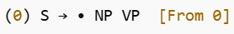  The dot "•" represents the current parsing position. Since NP is a non-terminal, we expand it:  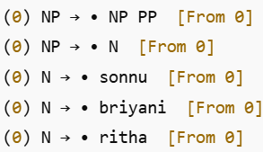  Step 2: Scanning "sonnu" (Position 1)  Since N → sonnu matches the first word, we advance the dot:  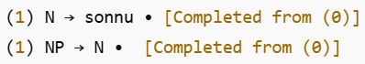  Since NP is completed, we move forward with S → NP VP:  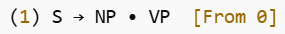  predict VP:  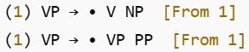  Step 3: Scanning "eat" (Position 2)  Since V → eat matches,advance:  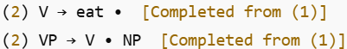  expand NP again:  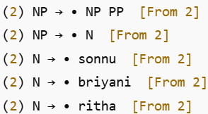  Step 4: Scanning "briyani" (Position 3)  Since N → briyani matches, advance:  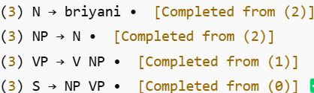  The sentence "sonnu eat briyani" is parsed correctly so far and is meaningful.  Step 5: Scanning "with" (Position 4)  Since P → with, match:  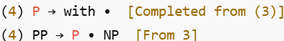  Expanding NP:  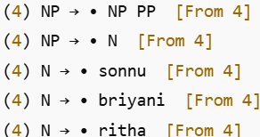  Step 6: Scanning "ritha" (Position 5)  Since N → ritha matches:  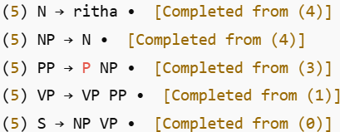  Since S → NP VP is complete, the sentence is successfully parsed.

